Date -20-12-2022
Event - Siddhattvam (A Quiz Challenge) For MCA

Date – 19th of December 2022
Time - 1.30 pm
Venue- IMCC Computer Lab, IMCC
IMCC, a Co-curricular cell conducted an Event Siddhattvam (A Quiz Challenge) for MCA students on the 19th of December 2022 @ 1.30 pm on online mode. We circulated this Poster, Rule Sheet, and Registration form one week before. MCA students registered by clicking on the following link or QR code published on the banner.
https://forms.gle/Pi1o7B8j9ZjY48XL8
Other instructions related to Quiz are communicated to participants on time.
Total 63 students from MCA participated in the Technical Quiz competition.
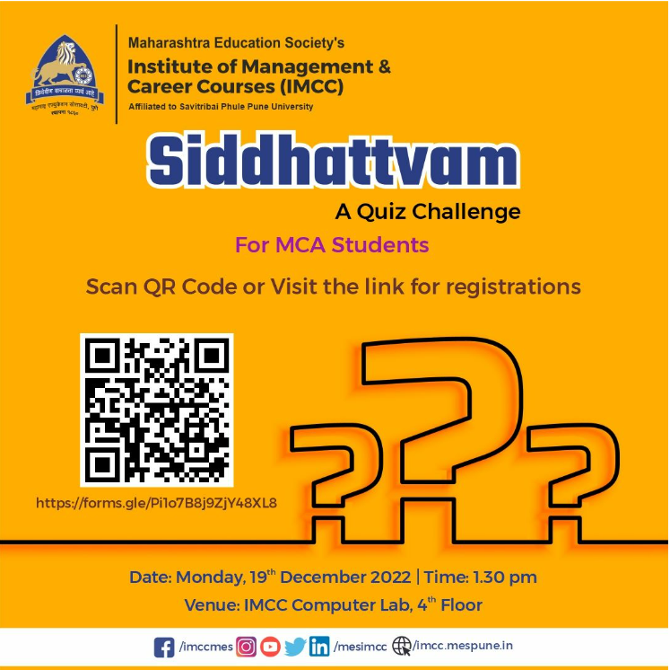
Some of glimpses of event
